Waste Classification Project

# Overview

This project implements a machine learning solution for classifying different types of waste materials from images. Using computer vision techniques and a Random Forest classifier, the system can identify six categories of waste: **plastic, biological, cardboard, metal, paper**, and **white-glass**. The goal is to assist in automated waste sorting and improve recycling efficiency.

# Image Processing Pipeline

Our system transforms raw waste images through a specialized preprocessing pipeline to extract meaningful features:

## Input and Output Examples

For each waste category, we transform colorful input images (left) into processed edge- detected grayscale images (right):

### Plastic:

Input: Blue plastic bag with handles

Output: Edge-enhanced grayscale highlighting the bag’s contour and structure

### Biological:

Input: Slice of bread with some mold spots

Output: Processed grayscale emphasizing the rounded shape and texture

### Cardboard:

Input: Brown cardboard with fold line and markings

Output: High-contrast edge detection revealing the cardboard’s lines and texture

### Metal:

Input: Aluminum foil package with “DIAMOND” branding

Output: Enhanced edges showing text and package shape

### Paper:

Input: Crumpled newspaper with print

Output: Complex edge pattern revealing folding structure and wrinkles

### White-glass:

Input: Broken clear glass

Output: Edge-detected fragments highlighting the sharp contours

## Preprocessing Steps

* Grayscale conversion to reduce color complexity
* Histogram equalization for improved contrast
* Sobel edge detection to highlight structural features

# Feature Extraction

For each processed image, we extract:

* Statistical features (mean, standard deviation)
* Histogram distributions (10 bins)
* Edge density measurements
* Texture analysis features
* Regional grid features (4×4 grid)

# Performance Metrics

The current model achieves the following performance:

* **Overall Accuracy:** 58.78%

|  |  |  |  |  |
| --- | --- | --- | --- | --- |
| **Category** | **Precision** | **Recall** | **F1-Score** | **Support** |
| **Plastic** | 0.54 | 0.41 | 0.47 | 198 |
| **Biological** | 0.68 | 0.74 | 0.71 | 190 |
| **Cardboard** | 0.57 | 0.69 | 0.62 | 173 |
| **Metal** | 0.46 | 0.45 | 0.45 | 132 |
| **Paper** | 0.65 | 0.71 | 0.67 | 211 |
| **White-glass** | 0.56 | 0.47 | 0.51 | 149 |

Table 1: Classification performance metrics for each waste category

## Key Observations

* Biological waste and paper are detected with the highest reliability
* Metal objects present the greatest classification challenge
* Plastic materials show good precision but lower recall

# Making Predictions

To classify new waste images, use the following code:

Listing 1: Prediction Script

def process_and_predict ( img_path ): img = cv2 . imread ( img_path )

processed = preprocess_image ( img , img_size =(128 , 128)) features = extract_features ( processed )

prediction = clf. predict ([ features ])[0] return img , processed , categories [ prediction ]

*# Example usage*

img_path = " path / to/ your/ waste / image . jpg "

original , processed , predicted_category = process_and_predict ( img_path )

print( f" Predicted ␣waste ␣category : ␣{ predicted_category }")

# Future Improvements

* Explore deep learning approaches (CNNs) for potentially higher accuracy
* Implement data augmentation to improve model generalization
* Add more robust feature extraction techniques
* Optimize hyperparameters for the Random Forest classifier
* Explore ensemble methods to combine multiple models
* Include more waste categories for finer-grained classification

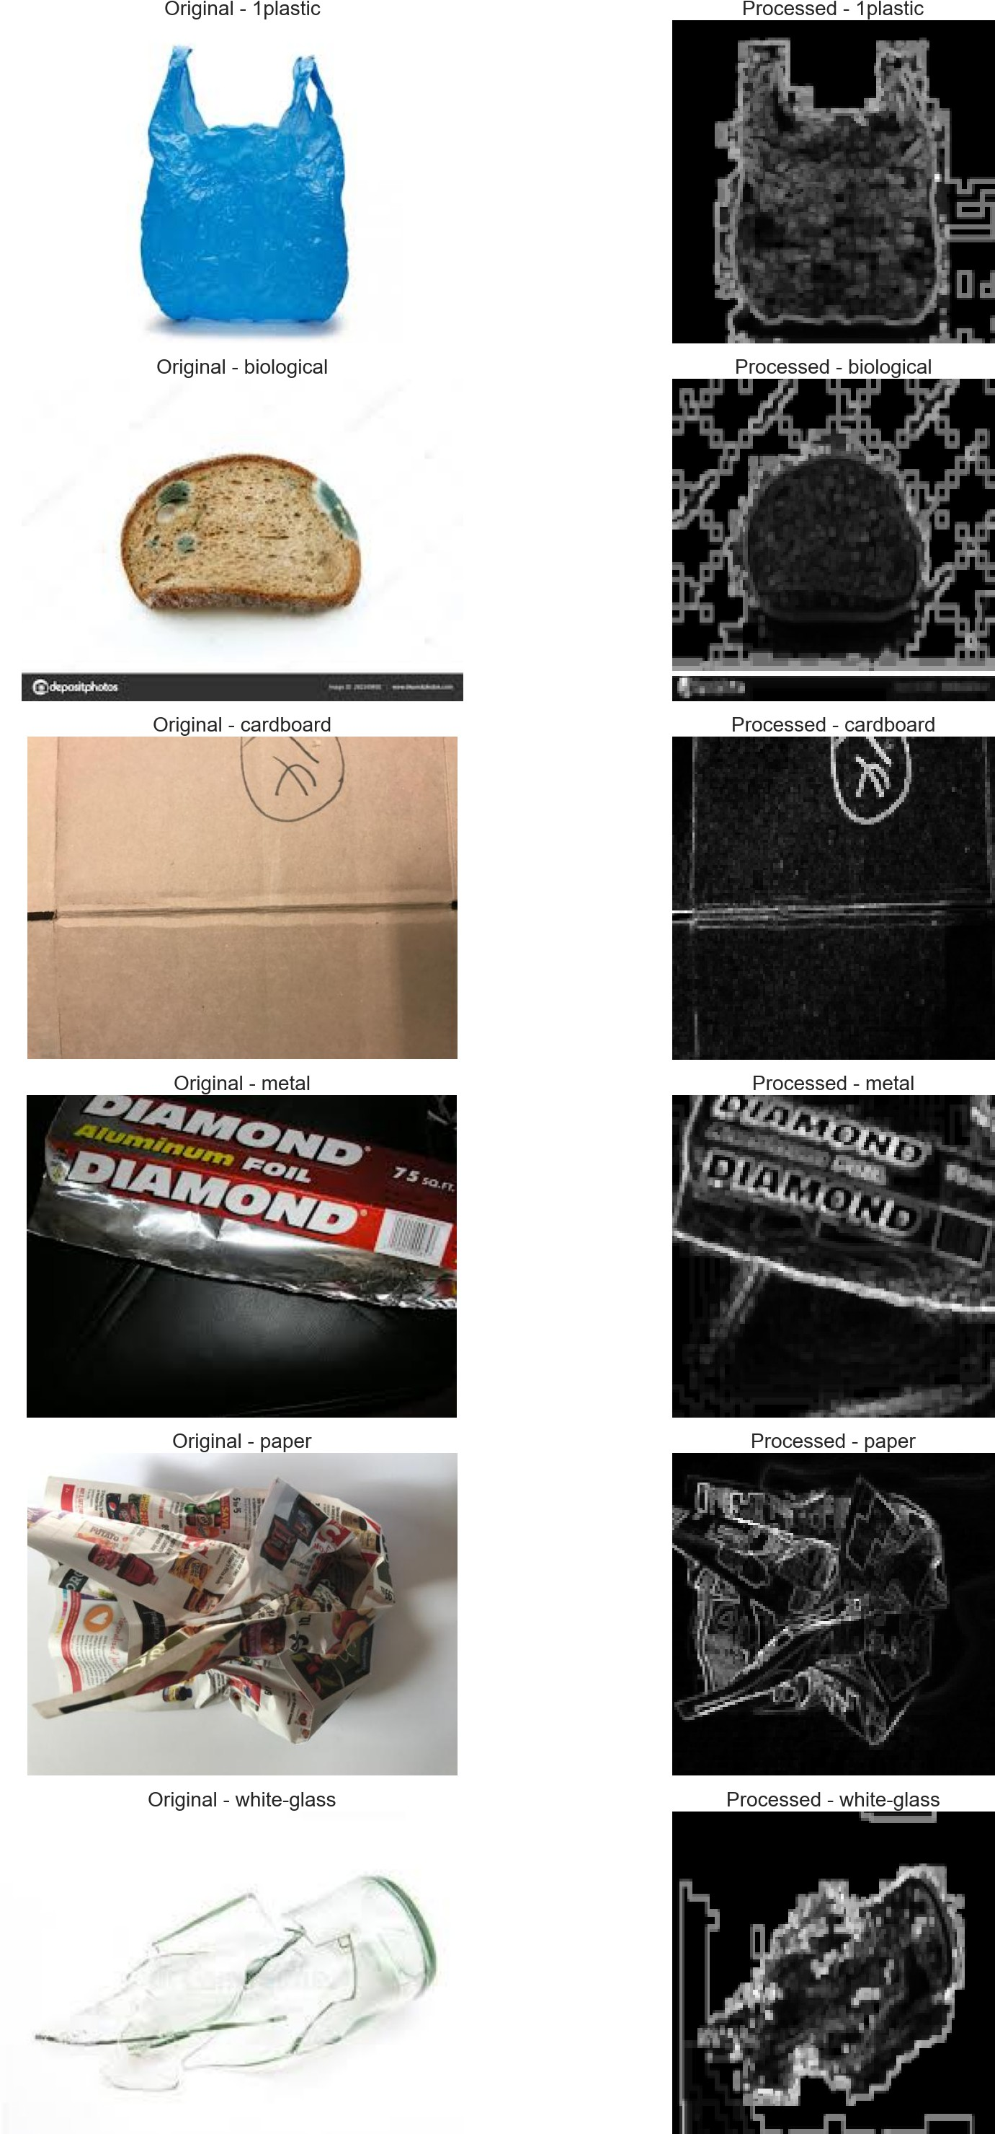

Figure 1: Display images before and After using image proccessing